


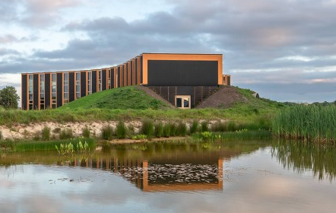
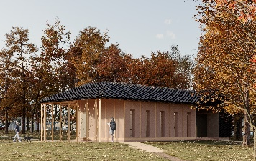

Aim of the group work.
To demonstrate that within EU there are mayor regulatory differences and that by learning from each other, we may succeed the transformation to more bio based better and faster. Based on the insights of the participants and “enablers” and “disablers” defined for B, D, DK, F and NL in FACT SHEETS provided by BBoBB, we aim to make an inspirational sample of enabling regulation that will offer a fast and sustainable track to green transition in bio based building. And we identify the mayor “disabling” regulations that need to be revised in order not to stop transition.

Summary of Enablers and Disablers for Biobased Building Materials
Enablers (Factors that Promote Use of Biobased Materials)
- Simplified Regulations and Standardization:
  - There is a need for new standards specifically designed for biobased materials to make their certification and acceptance easier across the EU.
  - Creation of free testing centers for biobased materials would help small businesses and innovators.
  - Setting carbon taxes or stricter building rules, along with subsidizing biobased materials, could incentivize usage.
- Economic and Financial Support:
  - Subsidies for biobased materials targeted at end-users could reduce costs and drive demand.
  - Investments and funding for the biobased supply chain to increase material availability.
  - Carbon credits throughout the value chain would provide financial incentives for adopting biobased materials.
  - Less tax for bio-based buildings or using recycled materials would provide a fiscal advantage.
- Education and Training:
  - Promoting awareness of biobased materials across different age groups would boost acceptance.
  - More training for engineers and the construction sector on using biobased materials is essential.
- Data and Research:
  - Gathering performance data on biobased materials through more experiments and real-world examples would provide confidence in their use.
  - CO2 emissions reduction requirements per square meter of construction would directly support biobased materials due to their lower carbon footprint.
- Health and Environmental Benefits:
  - Biobased materials offer health benefits and require less energy and installation, which can be leveraged as a strong selling point.
  - Fire safety standards harmonized across the EU for biobased materials would simplify approval processes.
- Policy Frameworks:
  - Regional circular economy models, like Friesland's, showcase how local demand and supply chains can support biobased materials.
  - Regulatory sandboxes could create safe spaces for biobased building material experiments.

Disablers (Factors that Hinder Use of Biobased Materials)
- Complex Certification and Testing:
  - Certification processes are lengthy and costly, especially for small companies. Harmonizing standards across the EU would make it easier for companies to comply.
  - Fire safety testing and other standards differ between EU countries, complicating the approval process for biobased materials.
- Cost and Market Barriers:
  - Biobased materials are often more expensive compared to traditional materials, making them less attractive for large construction projects.
  - The availability of biobased materials is still limited, which affects their scalability and use in large EU tenders.
- Knowledge Gaps and Social Pressure:
  - Lack of awareness and knowledge within financial institutions and insurance companies makes it harder to secure investments or insurance coverage for biobased construction.
  - Public perception and aesthetic preferences can also limit the adoption of biobased materials.
- Political and Industry Influence:
  - The traditional materials industry, or "black lobby," remains strong and resists the shift towards biobased materials.
  - National governments, like Denmark's, are perceived as not being ready or willing to fully support the transition to biobased building materials.

Proposals for action:
- Simplify certification and harmonize standards:
  - Create harmonized EU standards for bio-based materials, especially in the areas of fire safety and construction quality. This will make it easier for bio-based materials to gain approval in all EU countries.
  - Establish free testing centers for bio-based building materials so that small and medium-sized companies can more easily test and certify their products.
- Financial support and incentives:
  - Introduce subsidies or carbon bonus schemes for building projects using bio-based materials to reduce the price difference between bio-based and traditional building materials.
  - Tax incentives for buildings using bio-based or recycled materials will create an incentive for developers and owners to choose more sustainable solutions.
- Create a harmonized market:
  - Introduce a carbon footprint per square meter regulation for all new buildings, which will reward projects that use low-carbon materials, such as bio-based materials.
  - Promote a regulatory sandbox for experimentation with bio-based building materials, where new innovations and methods can be tested in practice without the usual regulatory barriers.
- Education and knowledge dissemination:
  - Expand EU education programs to include training for architects, engineers and construction companies on the use of bio-based building materials and communicate their sustainability, health and build quality benefits.
- Support regional economies and the circular economy:
- Increase support for rural areas and regions that can provide raw materials for bio-based construction, for example through agricultural support programs and NextGenerationEU funds. This will stimulate local economies and promote circular supply chains in the EU.
Benefits of acting now:
- Achieving the EU's 2030 and 2050 climate targets by reducing CO2 emissions from construction.
- Economic growth in regions that provide raw materials for bio-based construction.
- Improving health and comfort in homes through natural and sustainable materials.
- Making Europe a global leader in green building materials and technology.



